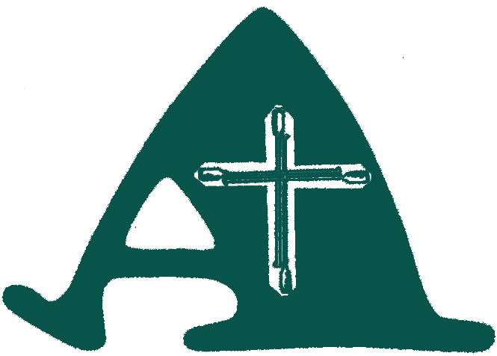
The Asheldham Centre - Booking Form
This Booking Form must be forward via electronic or post to:
Address: Barry Howard, 50 Marine Ave., Leigh on Sea Essex SS9 2JE
Email: asheldham@hotmail.co.uk

Name of Organisation

Name of group [if different from above].

Group Leader.

Contact Name [if different from above]..

Postal Address

Telephone No

Mobile Telephone No

E-mail address

Please state which of the above is most suitable for communication with you :

Date[s] required

(always check with the Centre Manager first before making a booking)

How many people in your party?

Overnight required Yes / No (Please delete)

What is your planned time of arrival on Day 1?..

What is your planned time of departure on the final day?

Please see the section on website ‘Prices & Booking’ for further detail on bookings.

Unless a deposit is received your booking is still only provisional and can be replaced by another group:
A 50% deposit is required with this form. The balance is required not less than 7 days before your arrival. Failure to send balance will cancel your booking.

Please make cheques payable to 'The Asheldham Centre'

